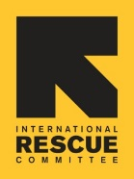
INTERNATIONAL RESCUE COMMITTEE, NIGERIA COUNTRY PROGRAM
CHILD PROTECTION FACT SHEET.

1. COUNTRY CONTEXT
The humanitarian crisis in the Northeast Nigeria is in its twelve-year, affecting some 17 million people within the Lake Chad region which shares borders with countries like Cameroun, Chad, and Niger and had forced millions to flee their homes across the region. It has been plagued with complex degrees of emergency including insurgency, youth agitations, climate change, disease outbreaks, and food insecurity. As insurgency continues, NSAGs have continued attacks on military formations, kidnappings of civilians including humanitarian aid workers have been on the rise, thereby making it difficult for INGOs to provide aid. High rate of unemployment and drug abuse have been identified to be triggers for youth and children recruitment into Armed Opposition Groups (AOGs). Struggles over resources and land, aggravated by the impacts of climate change, have intensified into communal conflicts, resulting in significant displacement of populations. This competition for resources has escalated tensions between herders and farmers, often leading to violent confrontations.
Rampaging gangs of armed bandits have engaged in violent acts, attacking, abducting, killing, and robbing and raping civilian population, and engaging in cattle rustling. Such activities cause large-scale displacements and population movement within the states, as well as across the international border of the Niger Republic. Due to a lack of humanitarian responses across the BAY states in Northeast and Northwest Nigeria (luck of funds and child protection actors), the humanitarian crisis has been exacerbated. According to Displacement Tracking Matrix (DTM) there are around 12, 1,075,893 internally displaced persons (IDPs) in the country and as the conflict continues, civilians are highly exposed to violence, abuse, exploitation, but also food insecurity, and disease outbreaks.

According to the Humanitarian Needs Overview (HNO)2023, approximately 8.3 million people (22% women; 59% children and 8% people with disabilities) in the northeast states of Borno, Adamawa and Yobe (BAY states) continue to be in dire need of humanitarian support. According to the HNO 2023, it is estimated that approximately 2.1 million people need child protection services due to the absence of child protection systems and community-based safety networks. Amongst these 2.1 million, the most vulnerable include children in IDP camps, secondary displaced children from closed camps, returnee children, children associated with armed groups (CAAG), unaccompanied and separated children, and children with disabilities. Girls are exposed to grave violations of children’s rights such as limited access to education, child marriage, sexual and gender-based violence, emotional and physical violence, and trafficking. Boys face the risk of forced recruitment, abduction, and re-recruitment by NSAGs, as well as trafficking. From the Protection Analysis update for North-East Nigeria, child protection needs have increased due to the sustained military offensive leading to high influx of people from NSAGs, inflation, high poverty rates and relocations of IDPs. With Borno state government efforts to close down IDP camps in the state, over 65,749 IDPs were transferred from four camps in MMC to their LGAs of origin between May 2021 and December 2021. According to the CCCM Sector, a further 73,292 IDPs were relocated from various IDP camps in MMC, Jere and Konduga LGAs to different regions in Borno State between January and August 2022. There are serious concerns about the safety and well-being of IDPs being relocated or returned, the voluntary nature (or lack thereof) of these movements, and their access to basic services and livelihoods in the areas they end up. One of the key issues that is being considered in 2023 if camp closures continue, is how to best provide services and support to this group, particularly if they end up in remote and insecure areas.

Overall, the situation in both Northeast and Northwest Nigeria continues to remain dire, with worsening economic indices, the Naira value is at its lowest level, energy prices are at record levels and a 30% inflation rate, largely driven by food inflation. Humanitarian response is urgently required to improve access to critical services for population in need.
The IRC Child protection team is implementing programs in Borno State (MMC/Jere, Konduga, Gwoza, Bama and Mongonu LGAs), Adamawa State (Michika, Madagali, Yola south and Numan LGAs) and Yobe State (Gujba and Damaturu LGAs), in Katsina State (Batagarawa and Katsina LGAs) and Zamfara State (Gusue and Anka LGAs).
SAFE Adolescent girls session for younger adolescents age (10 to 14) in Anka New model camp, Zamfara State

2. MORE ABOUT THE IRC CP PROGRAMS
The IRC-Nigeria child protection programs provide prevention and response services to children at risk of abuse, neglect or exploitation and those who are already experiencing violence, through five thematic areas: (1.) Child Protection Case Management, (2.) Structed Group Psychosocial Support for children/adolescents through Social Emotional learning (SEL) and Supporting Adolescents and their Families in Emergencies (SAFE), (3.) Positive parenting education for caregivers, (4.) integrated Nutrition and Child Protection programming (Brighter Futures) and (5.) Community based child Protection (CBCP) and prevention activities.

Child Protection case management services: IRC Nigeria has provided comprehensive case management service to 942 (484G, 458B) UASC and other at-risk children experiencing abuse, neglect, exploitation, and violence through trained CP caseworkers and with support from the CBCPCs, to improve the child immediate safety and wellbeing through the principle of best interest of the child, participation, coordination, and accountability for all children identified and registered for case management. The IRC also uses the Targeted Individual Assistance (TIA) as an emergency fund to assist particularly high-risk and urgent cases in need of one-time support for non-food items, medical referral and transportation. In addition, the IRC Nigeria is currently part of a child wellbeing Matters X A one year research project that aims to improve case management. Considering this is a critical response for children who have been abused, the IRC team will participate in a research that wants to strengthen the gaps in evidence between child wellbeing and the individual support received through case management.

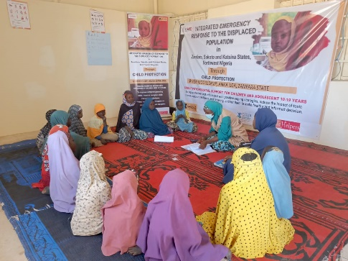
Structured Group Psychosocial Support (PSS): The IRC has reached 200 (102G, 98B) children between the ages of 6-11 years through Social Emotional Learning (SEL) sessions that support children to acquire and effectively apply skills, attitude, and knowledge to understand and manage emotions, set and achieve positive goals, feel and show empathy to others, create and maintain positive relationships with peer. Additionally, 1840 (929G, 911B) adolescent girls and boys between ages 12-19 years have completed the 12-week sessions of Supporting adolescents and their Families in Emergencies (SAFE). The sessions are coordinated and facilitated by trained SHLS facilitators, with onsite supervision and coaching by the IRC CP Assistants to promote ownership and sustainability of adolescent programs that promote/improve their peer-to-peer relationships, coping strategies, and the wellbeing of the adolescents girls and boys.

Positive Parenting Education: The IRC uses the Families Make the Difference (FMD) curriculum for caregivers of children 6-11 years and have reached a total of 1493 (881F, 612M) caregivers through the 12-weeks sessions. The sessions aim at promoting the well-being and safety of children and adolescents through enhancing parents/ caregivers stress management skills, encourage participation, improving and strengthening positive parenting practices at home, and supporting children and adolescent psychosocial needs.

Brighter future Programming: The integrated Child Protection-Nutrition programming also known as the Brighter Futures, aims at identifying and responding to children’s protection needs during screening for malnutrition at the outpatient therapeutic program (OTP) and stabilization center (SC), thereby reducing relapse cases and providing the caregivers with positive parenting skills to improve the developmental, behavioral and safety of malnourished children using the Caregivers Matter. A total number of 38208 (20685G, 17523B) malnourished children have been screened for child protection concerns in 2023.
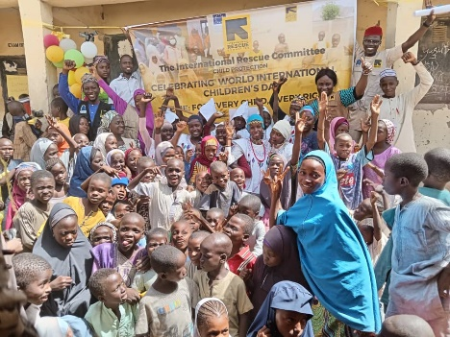
Community-based Child Protection and prevention activities: The IRC strongly collaborate and coordinate with the community-based child protection committees (CBCPCs), SHLS facilitators, and other relevant community-based organization, who are locals, influential and respected community members in the various communities. The IRC engages and strengthens the capacity of the relevant community-based stakeholder to safely identify and mobilized people during outreach activities, respond and or promptly refer cases for specialized services,Through field supervision visit, monthly meeting and workshops.
20th Nov. 2023 @ wuaro Jabbe during international children’s day celebration.

3. DONORS





IOM DTM Nigeria: Flash Report #120: Population Displacement North-west/North-central Nigeria 10 - 16 October 2022.
International Organization for Migration (IOM). Global Data Institute. Displacement Tracking Matrix (DTM). Nigeria – North-Central and North-West Displacement Report. 12 December 2023. https://dtm.iom.int/reports/nigeria-north-central-and-north-west-displacement-report-12-december-2023

